

FACULTY OF COMPUTING

SEMESTER 1, SESSION 2023/2024

SECP1513-TECHNOLOGY AND INFORMATION SYSTEM

SECTION 02

DESIGN THINKING

TITLE: COMPUTER NETWORK

Group 11

LECTURER: DR. ARYATI BINTI BAKRI

|  |  |
| --- | --- |
| Name | Matric No |
| YASMIN BATRISYIA BINTI ZAHIRUDDIN | A23CS0201 |
| NURUL ASYIKIN BINTI KHAIRUL ANUAR | A23CS0162 |
| ANIS SAFIYYA BINTI JANAI | A23CS0049 |
| NABIL AFLAH BOO BINTI MOHD YOSUF BOO YONG CHONG | A23CS0252 |
| LAU YEE WEN | A23CS0099 |

Table of Contents

**1.0 Introduction** 3

**2.0 Detail step and Description** 4

**2.1 Empathy** 4

**2.2 Define** 4

**2.3 Ideate** 4

**2.4 Prototype** 4

**2.5 Test** 4

**3.0 Detailed description** 5

**Problem** 5

**Solution** 5

**Team working** 6

**4.0 Design Thinking Assessment** 7

**4.1 During the end of the project demonstration** 7

**4.2 During the transition between design thinking phases** 7

**5.0 Design Thinking Evidence** 8

**5.1 The sample work by students working to solve the design challenge** 8

**5b. Record for each phase** 9

**6.0 Reflection** 12

**Work distribution table** 18

**Work Progress** 19

**8.0 References** 20

# **1.0 Introduction**

**Background**

In this 4IR era, the Internet is one of the most significant inventions of the 20th Century. With the growing number of geographically dispersed scientific collaborations and the expanding quantities of scientific data, users are finding it difficult to attain the highest level of network performance on a shared network. The maximum quantity of data that can be sent over your network at one time is referred to as bandwidth. Users on a network transmit data across network nodes in order to access and deliver files. Data can be transferred at a quicker rate if the speed of transmission is increased. A network with increased bandwidth also allows for more devices to be connected at the same time. That is, the larger the network, the more bandwidth is needed to handle the daily data transfer.

**Objective and overview of this project**

As students, we are frequently faced with heavy bandwidth usage on our school's network, where internet speed is extremely poor, causing us to waste a lot of time while waiting for the page to load. High bandwidth utilization also has an impact on how quickly users can upload and download files and media. To address this issue, our team developed a multipurpose router with several novel characteristics.

**About our model**

"Hex-Fi" is the name of our router. The term "Hex" refers to our router's hexagonal design, while the term "Fi" refers to our model's ability to transmit Wi-Fi signals. The router can be brought along anywhere and at any time. It is wireless and portable, making it simple to use. It allowed devices to use the 8 GHz frequency band, which has a bandwidth of 1,600 MHz and is suitable for sending massive volumes of data over short distances. For devices that are supported, this can assist in reducing interference and traffic congestion.

# **2.0 Detail step and Description**

## **2.1 Empathy**

Empathy is a process where we conduct an interview with people that are more experienced in computer networks. This is to really understand the respondent’s needs and get an idea of problems they are facing while handling the computer network.

## **2.2 Define**

Define is the process for us to identify the problem that our respondent has faced along their career. After we have interviewed the technician and lecturer in the faculty of computing, we have successfully identified their problem by understanding and analysing their answers that are mentioned in the interview session.

## **2.3 Ideate**

Ideate is the process where we can generate all the possible solutions to overcome the problem statements. In this stage, we have suggested a few different solutions based on the problem statements and we have concluded to choose the best solution among the other solutions.

## **2.4 Prototype**

Prototype is the process where we choose the most suitable solution to the problem that has been identified. Then, we create a model to help us get a clear view of the solution decided. The model is made of accessible material such as cardboard and coloured papers.

## **2.5 Test**

Test is a process where we show and explain our product to the users. The prototype helps users to have a better understanding on how the problem is solved by using our model. Also, we get feedback from users during this process which is needed to improve our model.

# **3.0 Detailed description**

## **Problem**

After having the interview sessions with one of the technicians and lecturer from our faculty, we found out that the connectivity inside the UTM is still not as fast as we expected it could be. This is because the usage of the connections inside the UTM is very large as everyone has at least two devices with them nowadays and some might be more than that. This will more likely cause high bandwidth of usage to happen as everyone is trying to stream and download their file at the same time.

Moreover, Wi-Fi signals will slow down due to network congestion. This is because there are too many requests for transferring data and communication are made at once over a small bandwidth capacity. Besides, this will also affect their connectivity to other devices and streaming music or videos properly.

## **Solution**

To solve this problem, our team has come up with the idea that we are going to invent a mini tri-band router which is called as Hex-Fi. This router contained 8GHz band inside and it can maximise up to 18Pbps per device. The connectivity will be a bit slower in the real world due to the environment of the user's place. This router can also accommodate high bandwidth usage which users don’t need to worry about the connection when using more devices to transfer the data.

Furthermore, the router that we invented can be accessed from far with higher speed and it is very convenient to carry around especially for students inside the UTM as it is a portable wireless router. It also has dustproof and waterproof features.

## **Team working**

Our group has split the work in this project into separate tasks. Yee Wen will mainly focus on video editing while Yasmin is assigned to interview the technicians and lecturers at Universiti Teknologi Malaysia (UTM). Furthermore, Asyikin, Aflah, and Anis will focus on the design of our prototype and the content of the report for this project. Although we all have been assigned with different tasks, we cooperate and help each other to make sure this task was successfully accomplished.

Throughout the process of design thinking, we faced some challenges. At first of the discussion, we couldn't present the issue in the computer network since there is a lot of it and we don't have any idea on how to do the prototype to solve the problem. Additionally, we also struggle with our time management because all of us have different timetables and club activities. Fortunately, each of us managed to have a group discussion and get to solve the problem in this project.

# **4.0 Design Thinking Assessment**

## **4.1 During the end of the project demonstration**

At the end of the project, we found that design thinking was an important step-by-step process that needed to overview the problem faced by the user. Furthermore, we also need to find the best solution to solve the problem by this process. From this project, we can say that it is not easy to make new models or prototypes for problems related to the network since the technology is evolving so quickly.

## **4.2 During the transition between design thinking phases**

During the initial stages of the design thinking process, we encountered certain challenges that revolved around a dearth of ideas and difficulties in effectively managing our time due to our busyness in studies. Despite these hurdles, we were able to overcome them and finish the project as a team. We managed to get together in our free time and complete the project together.

# **5.0 Design Thinking Evidence**

## **5.1 The sample work by students working to solve the design challenge**

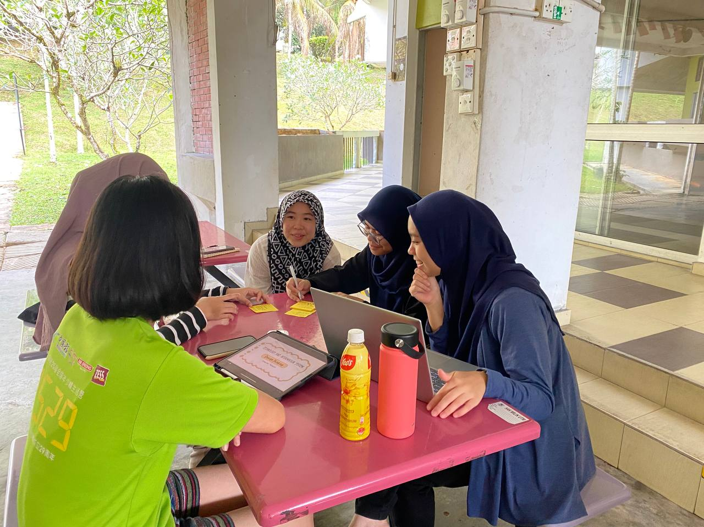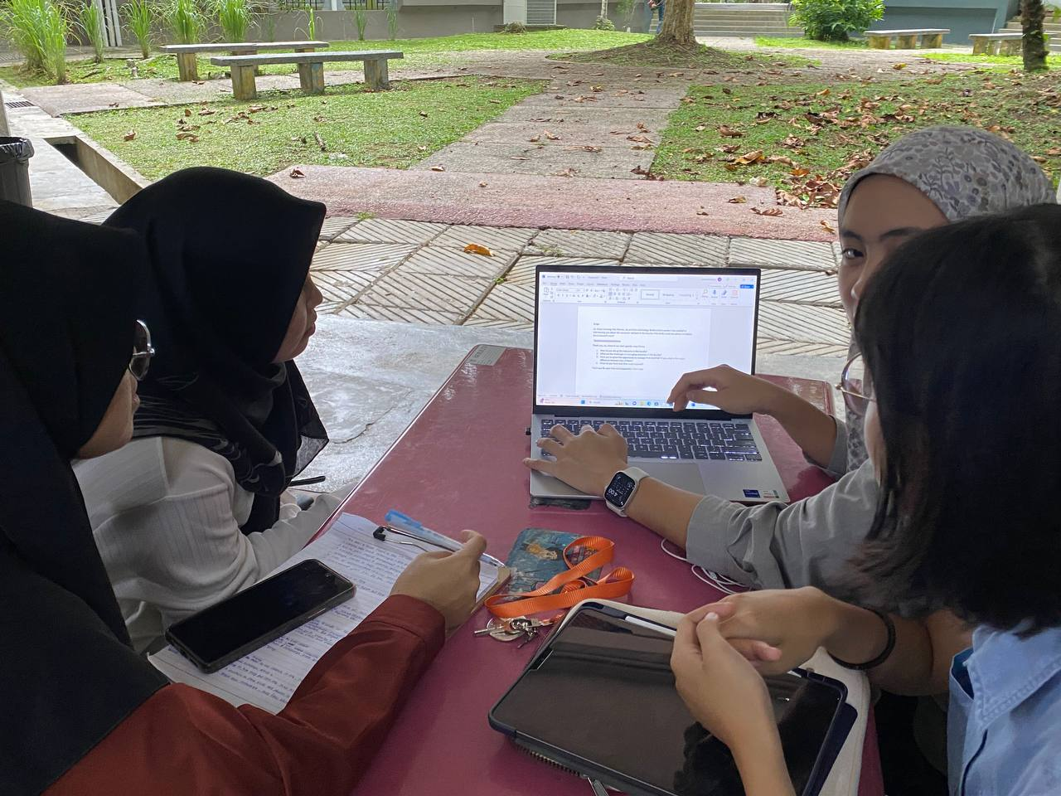

## **5b. Record for each phase**

* **Empathy**

The table below shows the questions and answers obtained from the interview.

|  |  |
| --- | --- |
| **Questions** | **Answers** |
| Could you please introduce more about yourself? | My name is Nurfazrina Binti Mohd Zamry and I am currently working as a senior lecturer in the faculty of computing. |
| What do you think can be improved in terms of network in our faculty? | In terms of the usage, in one particular time, all classes are using the network at the same time. So, the network might be slow because of the high bandwidth usage. |

|  |  |
| --- | --- |
| **Questions** | **Answers** |
| Could you please introduce more about yourself? | My name is Mohamad Shamsul Fitri Hj Sulaiman. I am a JA29 assistant engineer at the faculty of computing and have served for about 16 or 17 years. |
| What are the challenges in managing networks in this faculty? | I think one of the challenges is technological change. For instance, nowadays, all of the students use laptops and wifi is growing fast. However, students are not satisfied with the connection of the internet through wifi, so they need to use cable to connect it. |
| What do you think can be improved in terms of network in our faculty? | First, speed and connection and stability of the internet. The N28 building is well-established and was created in 1998. So, the network is stable and the connection is also good enough. Rarely will have network disconnection. But, N28a has internet problems. If the wifi maximum can accommodate 250 users only and all of the 250 users connect to the same wifi, the speed will become slow. |

* **Define**

The table shows the problem faced by the technician and lecturer.

|  |  |
| --- | --- |
| Problem | Description |
| Connectivity of the internet in the UTM is not as fast as it should be. | * High bandwidth usage occurs when everyone is using the internet at the same time. * One person has more than one device connected to the internet. |
| Wi-Fi signal will slow down from time to time | * Too many requests in transferring data. * Everyone is trying to download the files and stream music and video at the same time. |

* **Ideate**

In our discussion, we generate all possible solutions to the problems that have been identified.

|  |  |
| --- | --- |
| Solution | Reason |
| Create a new type of fibre optic cable that have a higher bandwidth usage | * A fibre optic cable can provide a higher speed of network but it will be costly and expensive. * Creating the cable with a recycled material may result in poor performance as it is not a good electric conductor. |
| Create a wireless router with higher frequencies which is 8GHz | * This will provide faster speeds and more stable connections. * The shorter waves make it less able to penetrate walls and solid objects. So, it provides internet at a shorter range. By making it portable, this issue won’t be a problem as it can be brought anywhere you go. |

* **Prototype**

After we had a lot of discussion in choosing the best solution for the people to use in order to have a faster connectivity to the internet, we sketched the ideas on the drawing as in figure 3 as this will be our guidance on how the product will be produced as in figure 4.

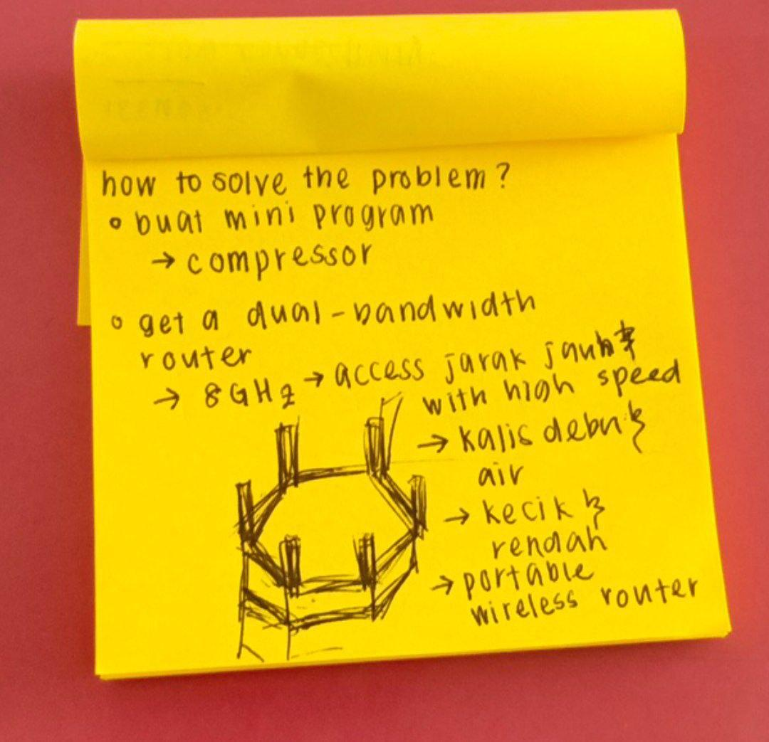 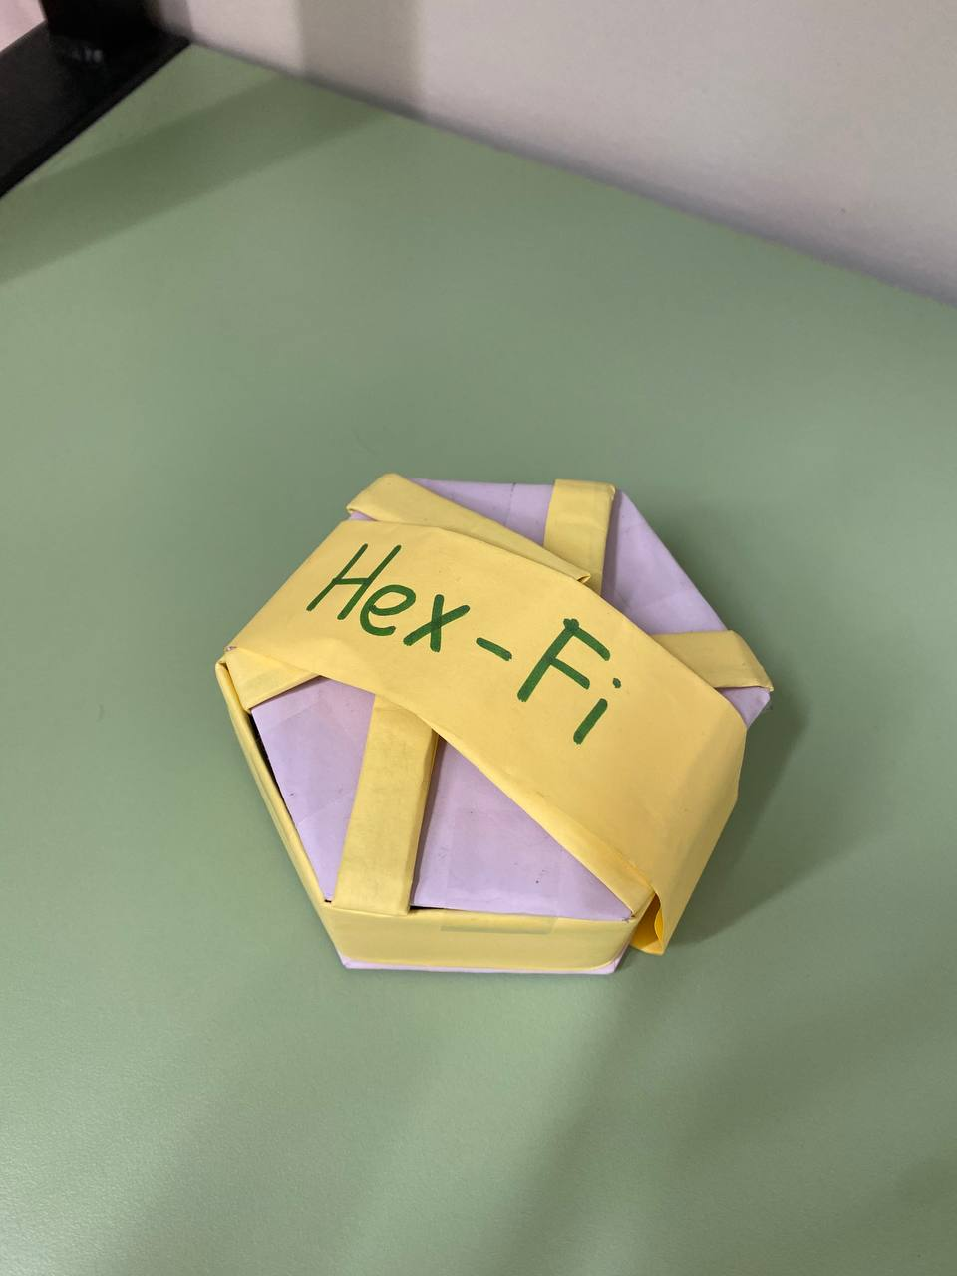 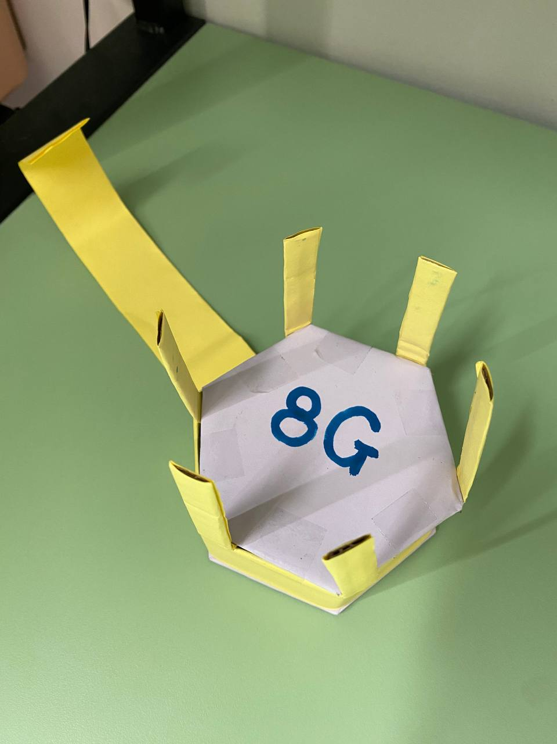

*Figure 3 Figure 4*

* **Test**

After the prototype is complete, we test our product to know if there is any improvement that can be made. Then, we demonstrate the product to the user and explain how our product can solve the problem of slow network connection.

# **6.0 Reflection**

|  |  |
| --- | --- |
| **Name** | **1.What is your goal/dream with regard to your course/program?** |
| **LAU YEE WEN** | My goal is to master one or more programming languages and to build a solid foundation in coding and big data problem-solving. Acquiring new abilities and enhancing existing ones is an achievable goal that supports my work and increases my chances of career advancement. Soft skills including time management, problem-solving, and communication can also help me develop the capacity to do more effective work. |
| **ANIS SAFIYYA** | My goal with regard to my course is to gain more knowledge in this field which is computing. In this modern era, technology is revolving fast and there are still a lot of things that have not been discovered yet. In order to keep up with the technologies that are continuously invented, my goal is to learn as much as I can and have a better understanding of it as right now, I have only covered the surface or the basics and there is a lot more for me to explore. |
| **NABIL AFLAH BOO** | My goal with regard to this program is to strengthen my basic programming knowledge. For example, C++ is one of the basic programming languages that I need to excel in terms to master other languages. This is because programming skills are the most crucial need in my course. Moreover, my goal is also to enhance my soft skills as it is important to deal with people in the future. |
| **NURUL ASYIKIN BINTI KHAIRUL ANUAR** | My goals for this course are to improve my programming abilities for use in the future. In addition, I wish to become proficient in a variety of programming languages and acquire knowledge more about database skills. I would like to expand my understanding and skills to stay updated with the latest trends and innovations in this industry. Moreover, I crave the opportunity to develop my soft skills regarding my course. |
| **YASMIN BATRISYIA BINTI ZAHIRUDDIN** | As the technology keeps on improving day by day, I personally think that there are so many improvements that can be made so that the product could be more accurate and convenient. So, my goal in this course is to be able to create an application or AI devices for people so that all activity can be done by the technology and decrease the human labour. Therefore, in order to generate and create an innovative idea for the world, we have to produce generations that are mastered in STEM and especially computer science. |

|  |  |
| --- | --- |
| **Name** | **2.How does this design thinking impact on your goal/dream with regard to your program?** |
| **LAU YEE WEN** | This project taught me how important it is for teams to collaborate because each member brings a unique set of ideas to the table. As a result, while we collaborate on this project, we need to talk with one another about our thoughts. This is because it takes more than one person to make this project a success. Additionally, this project also has an impact on building my self-confidence. I could recognize that I also possess the power to innovate using my knowledge, abilities and creativity. |
| **ANIS SAFIYYA** | This design thinking process has sharpened my problem solving skill. The reason is that this skill is required in order to complete this project and I am able to apply it in my daily life in the future. For instance, there are a lot of problems that my group needs to face during this project and the contribution of each member showed me other perspectives on how to solve it. Therefore, it made me realise that for every problem, there must be a solution and I should see the issue in many ways in order to solve it. |
| **NABIL AFLAH BOO** | This design thinking has taught me to be a productive person. The reason is that being productive when doing the project with the groupmates will definitely increase the work progress. For instance, we always held a meeting together to discuss and plan for our part in this project and share our thoughts with each other. Thus, we can finish our project according to the time given. |
| **NURUL ASYIKIN BINTI KHAIRUL ANUAR** | This design thinking had a significant impact on my goals by improving my communication skills also our teamwork because this process requires a conversation between my teammates and interviews with other people. The design thinking process also contributes to my critical thinking skills because I need to analyze and evaluate the problem and also at the same time devise the solution to the problem. As a result, these skills really helped me to gain knowledge in this industry by doing some research about the problems we faced. |
| **YASMIN BATRISYIA BINTI ZAHIRUDDIN** | In my opinion, design thinking gives a really big impact on achieving my goal. This is because my goal or dream is quite big, therefore with the knowledge of design thinking ideas, I could break the big problem into smaller pieces. When the problem has been broken into a different phase, I could focus on what could be done first and so on. Therefore, there will be no point missed, and the outcome will be the same as I imagined. |

|  |  |
| --- | --- |
| **Name** | **3.What is the action/improvement/plan necessary for you to improve your potential in the industry?** |
| **LAU YEE WEN** | Some enhancements are required to maximize my potential in this industry. In my point of view, my understanding of the corresponding fundamentals of computer networks has to be strengthened. The reading of the paper and my investigation were the causes. Too many terms that I am not fully aware of cause me feeling confused before I begin writing my report. My lack of foundational knowledge and expertise in this area is the main cause. Therefore, before I go further, I must methodically acquire the knowledge associated with this issue. |
| **ANIS SAFIYYA** | To improve my potential in the industry, I would improve my teamworking skills. Teamwork is essential as every project requires good communication and cooperation between team members for it to be successful. With great teamwork, any obstacles and problems that occur can be solved efficiently and the work delegation will help manage the project faster. Other than that, I also plan to read more articles about technology so that I can keep up with the technology trends and innovations. |
| **NABIL AFLAH BOO** | To improve my potential in this industry, I would improve my problem solving skills. From what I have contributed in this project, I noticed that it is important for me to have a lot of ideas when doing the brainstorming process. It is also important in the industry as I need to find the best solution for my customers' problems. Other than that, I also need to enhance my time management skills. This is because it won’t be a rush for me to finish up my project if I plan my time properly. |
| **NURUL ASYIKIN BINTI KHAIRUL ANUAR** | I think the improvement that need to develop my potential in the industry is that I need to have better soft skills with others. These skills include time management, problem-solving, and also communication skills among others. I need to have better communication skills because discussion matters in the group or society to have a better solution. From this design thinking process, I also realized that having creative thinking in solving problems is very important to come up with an effective solution. Other than that, I need to improve on how to manage time properly to have better performance and develop self-discipline. |
| **YASMIN BATRISYIA BINTI ZAHIRUDDIN** | Firstly, the improvement that I have to do in order to improve my potential in the industry is that I have to increase my knowledge in the case study that I’m doing by reading a lot of articles and asking all the experts so that I could generate more ideas and solutions that can be improved more. Secondly, the things that I can improve are my communication skills. This is because, in order to create something, I have to get exposed and talk to a lot of people and ask them what problems that they’re facing so that I could fix it using the technologies. Lastly, I have to increase my team working skills. This is because, in the industry I’m not working alone, I’m working together with a lot of people from my department and so on. Therefore, to come out with an amazing outcome or product, I have to work together with them till the end of the process. |

**7.0 The task for each member**

## **Work distribution table**

|  |  |  |  |  |  |  |
| --- | --- | --- | --- | --- | --- | --- |
| **Name** | | **LAU YEE WEN** | **YASMIN BATRISYIA BINTI ZAHIRUDDIN** | **ANIS SAFIYYA BINTI JANAI** | **NURUL ASYIKIN BINTI KHAIRUL ANUAR** | **NABIL AFLAH BOO BINTI MOHD YOSUF BOO YONG CHONG** |
| **Tasks** | **Interview, Discussion, Prototype and Test Sections** | Interview( Empathy), Producing Prototype and Test | | | | |
| Discussion for Define and Ideate Stages | | | | |
| **Documentation and Presentation** | Editing videos and videographer | | Slide Presentation | | |
| **Report** | Progress Tracking | Detail step and descriptions for each phase | | Detail descriptions about problems, solution and team working | |
| Introduction | Design thinking assessment | | | |
| Design Thinking Evidence, Reflection and References | | | | |
| Work distribution table and Work Progress | Merge and compile the report | Final Review and Feedback | | |

## **Work Progress**

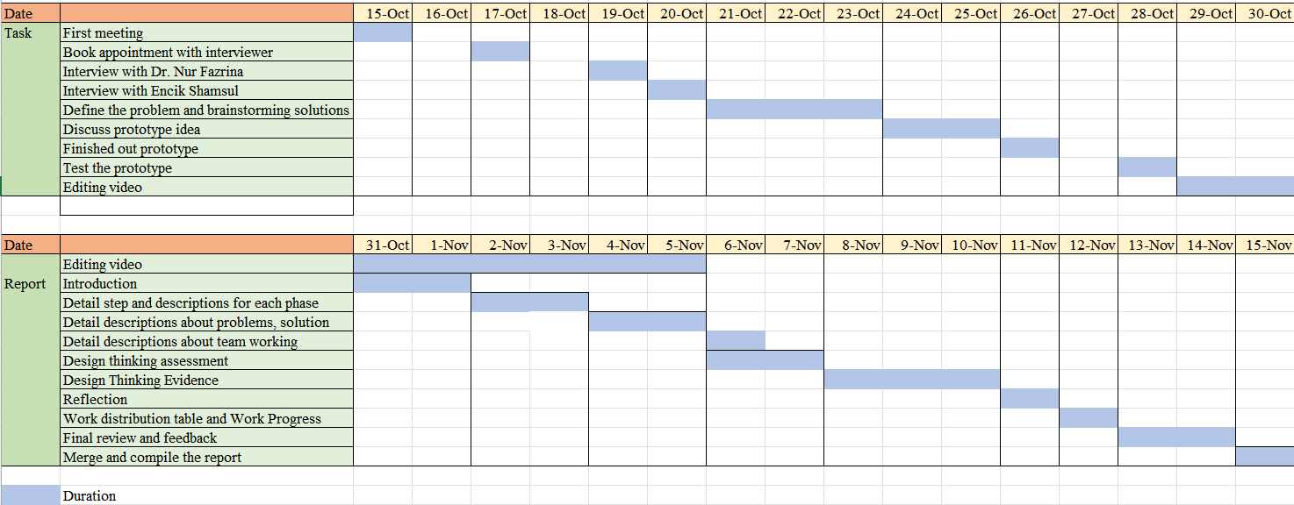



Video link: https://youtu.be/__oFY8RwpXE?feature=shared

# **8.0 References**

1. Ir Team.(n.d). A Guide To Network Congestion: What It Is, Causes, and How To Fix It. <https://www.ir.com/guides/network-congestion>
2. Alibaba Cloud. (n.d). Troubleshooting and solving the problem of high bandwidth in Windows instance. <https://www.alibabacloud.com/help/en/ecs/support/troubleshooting-and-solving-the-problem-of-high-bandwidth-usage-in-windows-instances>
3. Anwar M. (2022, March 9). What is 8G Network? How fast is 8G. <https://alltechnologytrend.com/what-is-8g-network-how-fast-is-8g/>
4. W. Yoo and A. Sim, "Network bandwidth utilization forecast model on high bandwidth networks," 2015 International Conference on Computing, Networking and Communications (ICNC), Garden Grove, CA, USA, 2015, pp. 494-498, doi: 10.1109/ICCNC.2015.7069393.